**Mockito Exercises**

**Exercise 1: Mocking and Stubbing**

**Code:**

public class MyServiceTest {  
   
 @Test  
 public void testExternalApi(){  
  
 ExternalApi mockApi = Mockito.*mock*(ExternalApi.class);  
 *when*(mockApi.getData()).thenReturn("Mock Api");  
 MyService myService = new MyService(mockApi);  
 String result = myService.fetchData();  
 *assertEquals*("Mock Data",result);  
 }  
}

**Output:**

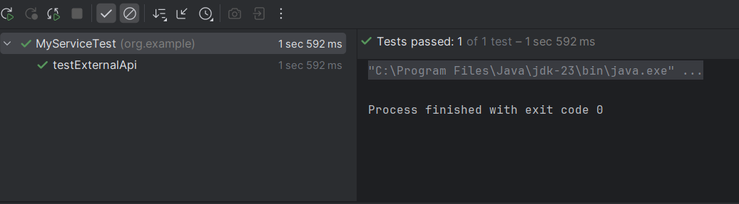

**Exercise 2: Verifying Interactions**

**Code:**

import org.junit.Test;  
import org.mockito.InjectMocks;  
import org.mockito.Mock;  
import org.mockito.Mockito;  
  
import static org.mockito.Mockito.*verify*;  
import static org.mockito.Mockito.*when*;  
  
public class MyServiceTest {  
 @Mock  
 private ExternalApi externalApi;  
  
 @InjectMocks  
 private MyService myService;  
  
 @Test  
 public void testExternalApi(){  
  
 ExternalApi mockApi = Mockito.*mock*(ExternalApi.class);  
 *when*(mockApi.getData()).thenReturn("Mock Api");  
 MyService myService = new MyService(mockApi);  
 myService.fetchData();  
 *verify*(mockApi).getData();  
 }  
}

**Output:**

